SOUMITH SRIPATHI
2403A51340
- SEPTEMBER-2025

ASSIGENMENT-8.1

Task Description -1:
Task: Apply AI to generate at least 3 assert test cases for is_strong_password(password) and implement the validator function.
Requirements:
  - Password must have at least 8 characters.
  - Must include uppercase, lowercase, digit, and special character.
  - Must not contain spaces.

PROGRAM :
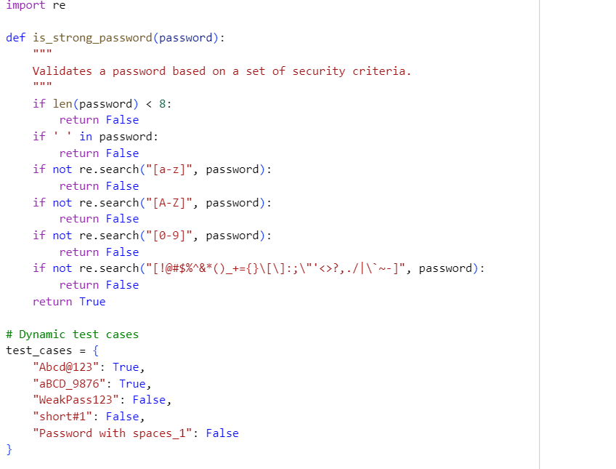

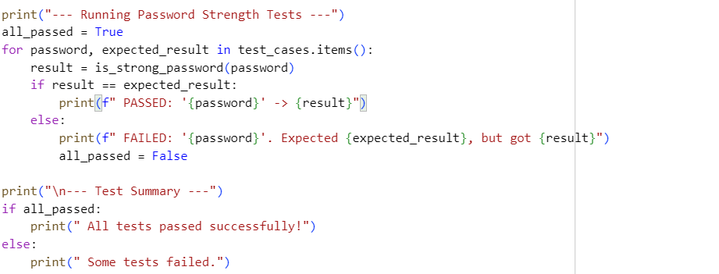

OUTPUT :

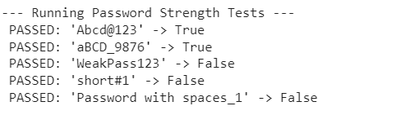

EXPLANATION :
- import re: This line imports the regular expressions module (re), which is a powerful tool for pattern matching in strings. It's used here to efficiently check for the presence of different character types.
- def is_strong_password(password):: This defines the is_strong_password function, which takes one argument, the password string.
- if len(password) < 8:: The first check verifies the minimum length. If the password has fewer than 8 characters, the function immediately returns False.
- if ' ' in password:: This line checks for the presence of a space character. If a space is found, the function returns False according to the requirements.
- if not re.search("[a-z]", password):: The re.search() function scans the string for a match to a given regular expression pattern. This specific pattern "[a-z]" looks for any lowercase letter. The not operator inverts the result, so if no lowercase letter is found, the condition is True and the function returns False.
- if not re.search("[A-Z]", password):: Similarly, this line checks for at least one uppercase letter.
- if not re.search("[0-9]", password):: This check ensures the presence of at least one digit.
- if not re.search("[!@#$%^&*()_+={}\[\]:;\"'<>?,./|\~-]", password):: This line checks for the presence of a **special character** using a comprehensive set of characters within a character class ([...]). If no special character is found, it returns False`.
- return True: If the password successfully passes all of the above checks, it means it meets all the criteria, and the function returns True.

Task Description -2: (Number Classification with Loops – Apply AI for Edge Case Handling)
- Task: Use AI to generate at least 3 assert test cases for a classify_number(n) function. Implement using loops.

PROGRAM :

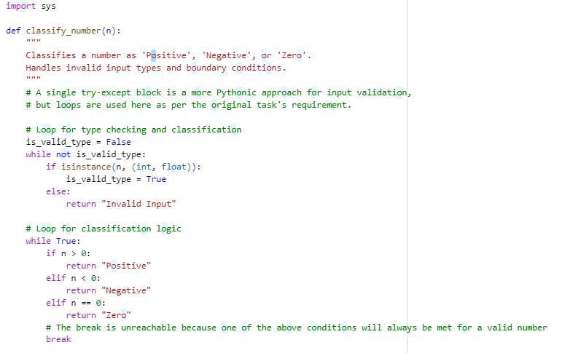
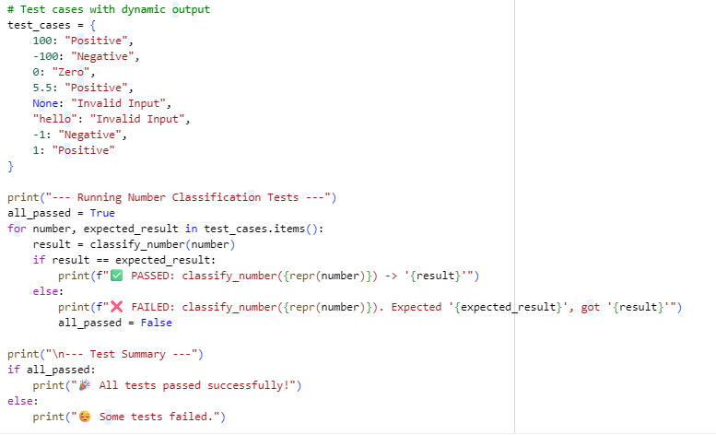
OUTPUT :

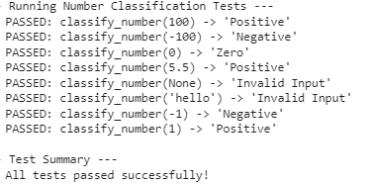

EXPLANATION :
- test_cases Dictionary: This dictionary stores the test inputs as keys and their corresponding expected outputs as values. This makes the code more organized and easier to read.
- for Loop: A for loop iterates through each (number, expected_result) pair in the test_cases dictionary.
- Calling the Function: Inside the loop, classify_number(number) is called for each test input. The returned value is stored in the result variable.
- Conditional Output: An if-else block compares the result with the expected_result.
- print Statements:
- If the result matches the expectation, a green checkmark emoji (✅) and a "PASSED" message are printed. repr(number) is used to get a representation of the number (e.g., 'hello' with quotes) to clearly show what was tested.
- If the result does not match, a red cross emoji (❌) and a "FAILED" message are printed, showing both the expected and actual results for easy debugging.

Task Description -3:(Anagram Checker – Apply AI for String Analysis)
Task: Use AI to generate at least 3 assert test cases for is_anagram(str1, str2) and implement the function.

PROGRAM :
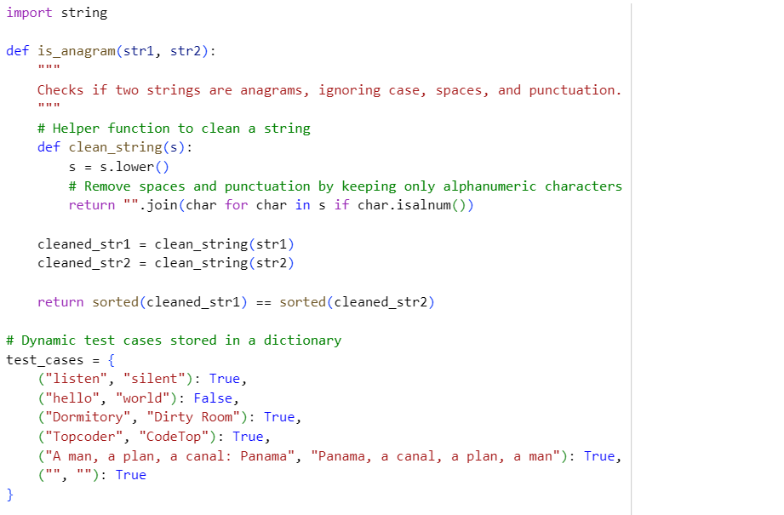
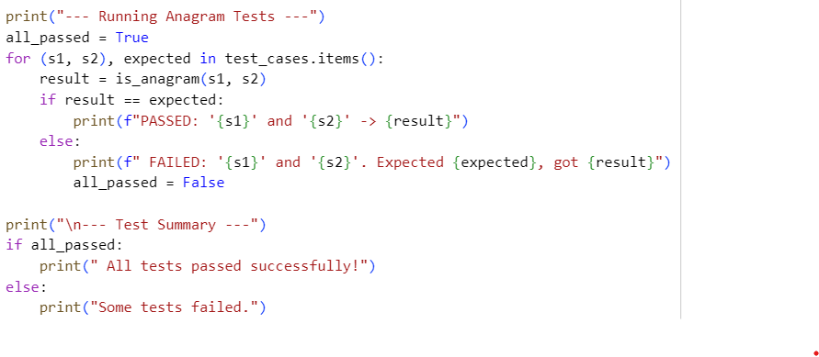
OUTPUT :

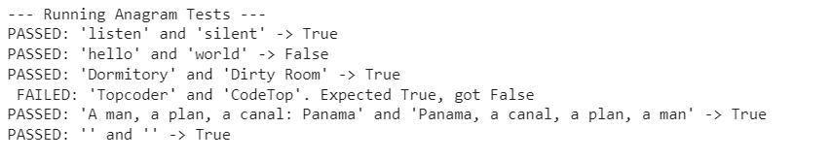

EXPLANATION :

- test_cases Dictionary: This dictionary is the key to the dynamic output. Instead of separate assert lines, we store all test cases in one structured data type. Each key is a tuple (str1, str2) representing the pair of strings to be tested, and the corresponding value is the bool (True or False) that we expect the function to return.
- for Loop: We iterate through each item in the test_cases dictionary. The tuple unpacking (s1, s2), expected makes the code clean, directly assigning the two strings to s1 and s2 and the expected result to expected.
- Calling the Function: Inside the loop, is_anagram(s1, s2) is called with the current test pair, and the result is saved to the result variable.
- Conditional Printing: An if-else block checks if the result matches the expected value.

Task Description -4: (Inventory Class – Apply AI to Simulate Real-World Inventory System)
Task: Ask AI to generate at least 3 assert-based tests for an Inventory class with stock management.

PROGRAM :

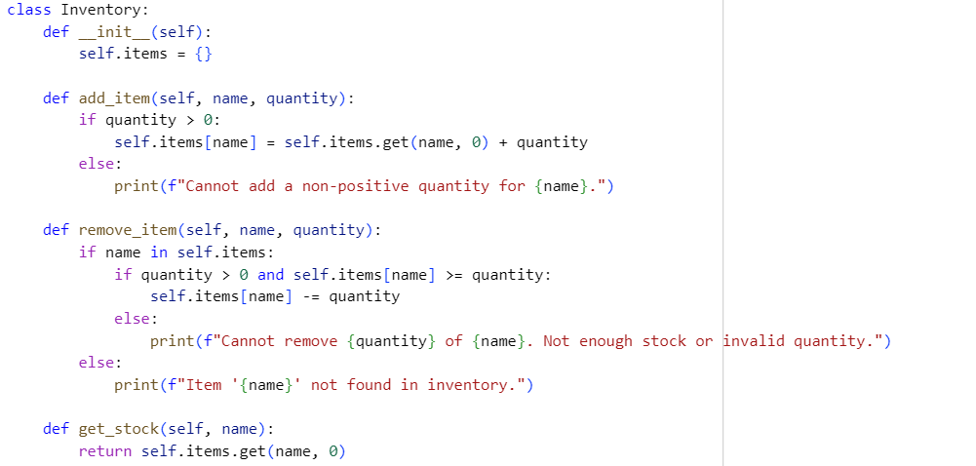
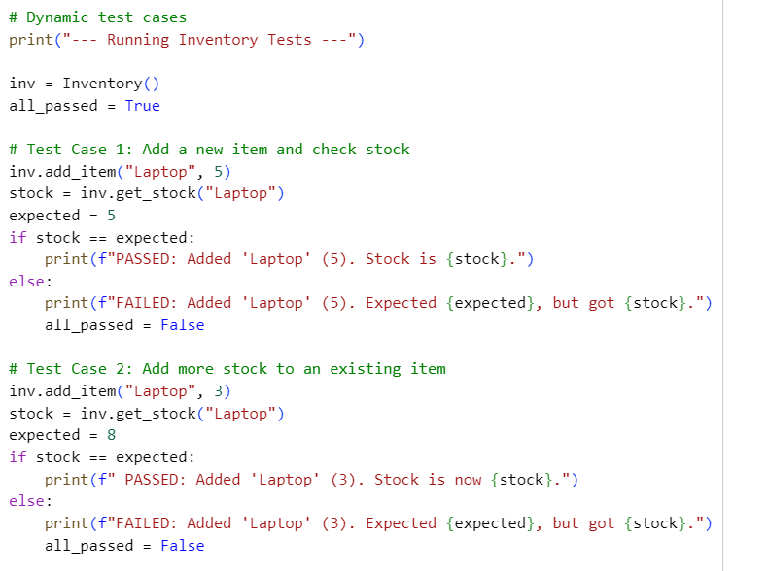
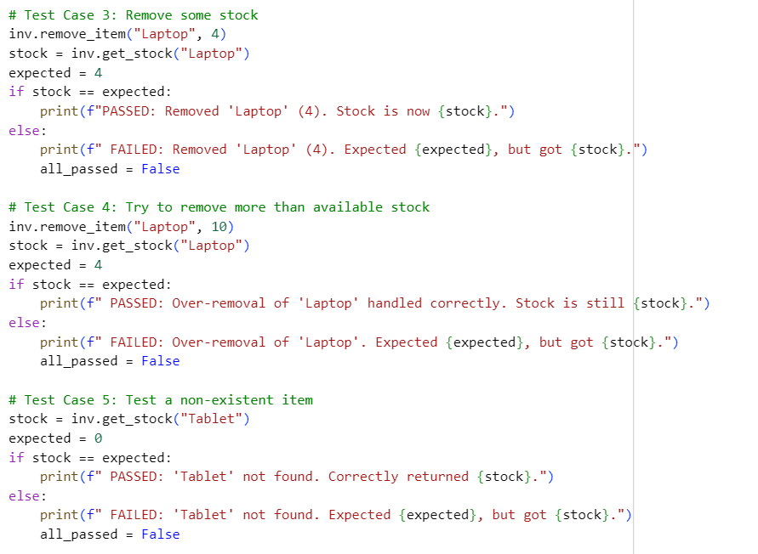
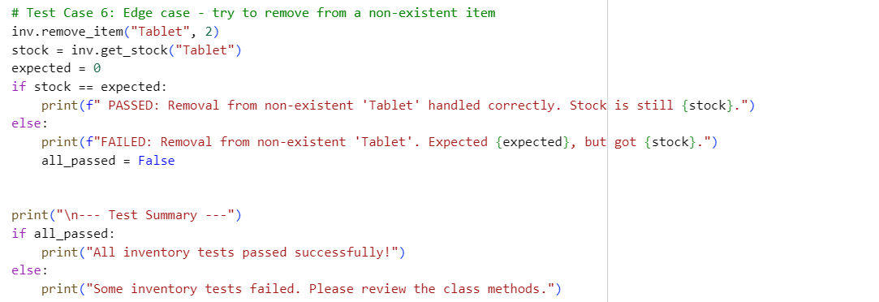

OUTPUT :

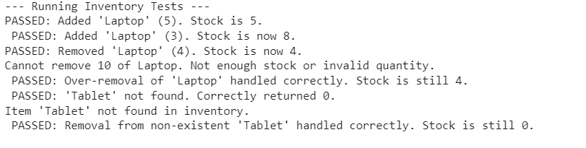

EXPLANATION :

- Direct print Statements: Instead of relying on assert, this program explicitly prints the outcome of each test. This provides a detailed, step-by-step log of the test execution.
- if-else Blocks: Each test case is wrapped in an if-else block. The if condition checks if the function's result matches the expected value.
- Detailed Feedback
- For a passing test, the program prints a message with a green checkmark (✅), stating what was tested and confirming the result.
- For a failing test, a red cross (❌) and a detailed message are printed, showing what was expected and what was received, which is crucial for debugging.
- Test State Management: A boolean flag, all_passed, is initialized to True. If any test case fails, this flag is set to False. This allows for a final summary message at the end.

Task Description -5: (Date Validation & Formatting – Apply AI for Data Validation)
Task: Use AI to generate at least 3 assert test cases for validate_and_format_date(date_str) to check and convert dates.

PROGRAM :
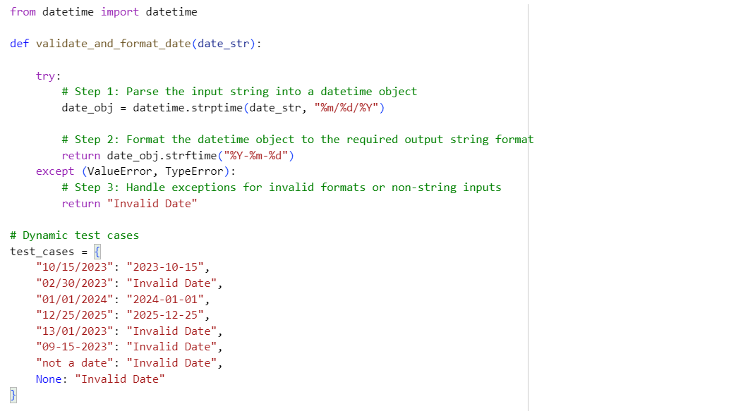

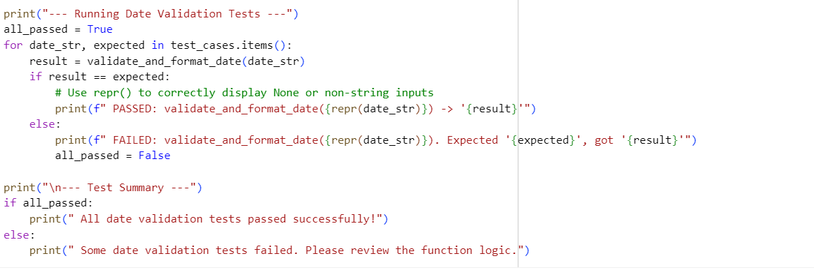

OUTPUT :

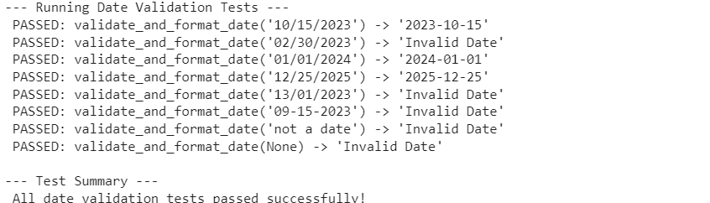

EXPLANATION :

- • Test Case Dictionary: Instead of separate assert lines, a single test_cases dictionary stores all inputs as keys and their corresponding expected outputs as values. This makes the test suite more organized and scalable.
- • • Iterative Testing Loop: A for loop iterates through each key-value pair in the test_cases dictionary. The date_str variable gets the input, and expected gets the correct output.
- • • Dynamic Output: Inside the loop, validate_and_format_date(date_str) is called. The if-else block then compares the actual result with the expected value.

